

THE IMPROVEMENT KATA POSTERS – A You-Are-Here Map for Scientific Thinking

The Improvement Kata Posters are a visual tool that illustrate a four-step scientific pattern for pursuing goals. They work hand-in-hand with the Experimenting Record and the Coaching/Reflection Questions.

As students engage in activities or assignments, you can use the poster to help them agree where they are in the process and internalize both the scientific pattern of working and the idea of a threshold of knowledge. While students naturally focus on the immediate content of the task at hand — the problem they are trying to solve — referencing the poster helps keep their attention on the broader, underlying pattern of scientific thinking they are practicing.

1) What are the Improvement Kata Posters?

The posters serve as a roadmap for navigating toward challenging goals along uncertain or unpredictable paths. They can help students visualize the overall iterative cycle of setting goals, experimenting, and discovery/learning that they are practicing. The poster stress that learning is not linear nor entirely predictable.

The Improvement Kata Posters illustrate the following four repeating steps for working toward goals:
- Understand the Direction or Challenge (What is the long-term goal?)
- Grasp the Current Condition (Where are you now?)
- Establish the Next Target Condition (Where do you want to be next?)
- Experiment Toward the Target Condition (To overcome obstacles and move the Threshold of Knowledge.)

The posters also highlight that scientific thinking is more than just experimenting, in that it involves defining objectives (both near-term and longer-term) and repeatedly assessing where one currently is. The entire, repeating process that the posters show a practical scientific-thinking way that can be applied in education, workplaces, communities, politics, and everyday life.

Example (Five different posters are available for downloading)
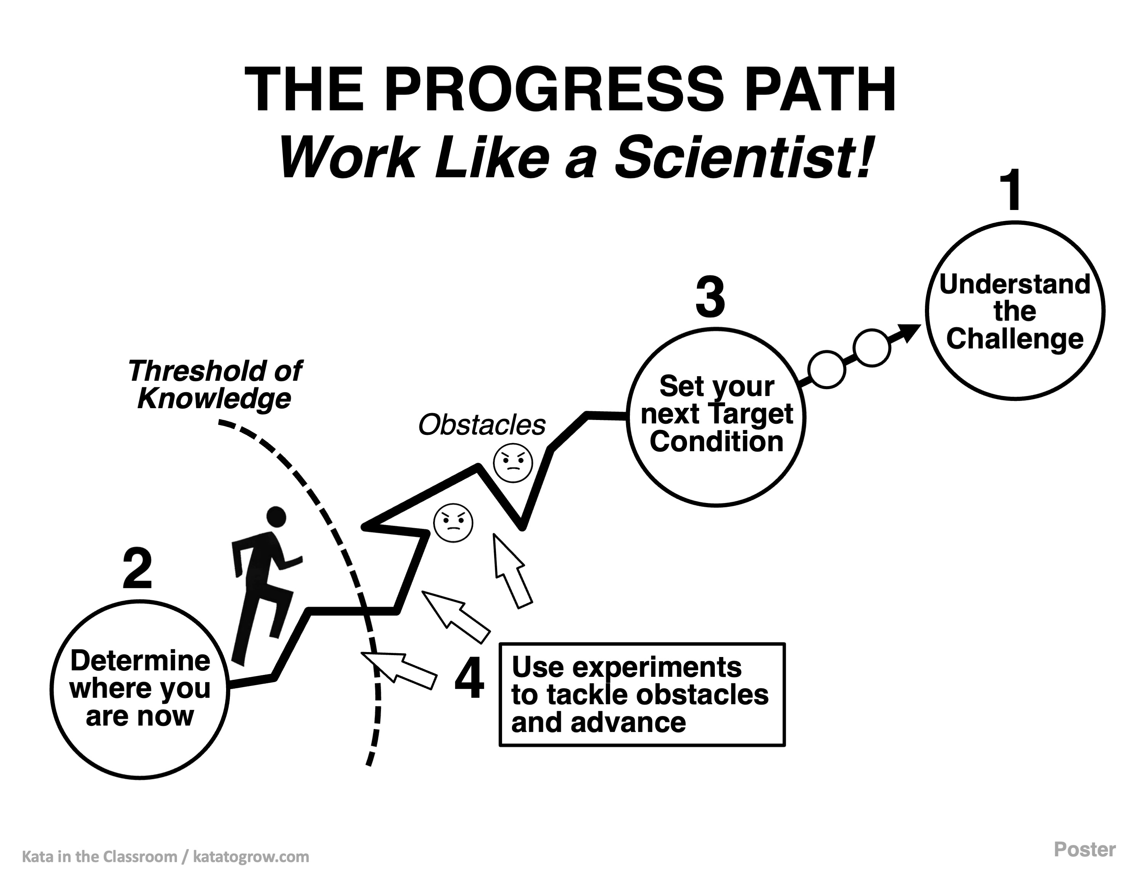

2) How to Use the Improvement Kata Posters.

The educator can display an Improvement Kata Poster at any time. Five versions are available for download on the Kata in the Classroom website. Select whichever version you like best.

As students practice a scientific-thinking approach, they may begin to internalize it as a natural way of viewing and interacting with the world. At this level of mastery, a student can see all the steps of the Improvement Kata as a whole and move fluidly among them, adapting to the situation as needed. Over time, this process can become almost automatic.

Before students reach that level, however, it can be helpful to have a visible reference point that both educators and students can use during daily practice. The poster provides that scaffold and can support class discussions or coaching conversations. For example, an educator might point to the poster and ask:

- “Let’s pause—where do you think we are in this process?”
- "Where are you now in these steps?"
- "What should we do next?"
- "What is your current knowledge threshold?"
- "What obstacle are you currently working on?"

Students can also use the posters—or a printed or digital image of one—individually to plan and track their progress or reflect on their learning process.

Additionally, the four steps in the posters can serve as a helpful outline for students or student teams as they share the story of their project.

3) Why Use an Improvement Kata Poster?

Using a poster helps reinforce a consistent language and process for scientific thinking. It also provides a clear, visual way to engage students by asking questions like, “Where are you now?”

The poster makes the often-invisible process of scientific problem-solving visible and concrete, helping students better understand how the steps fit into the overall picture.

